Contents

Abstract 1

Introduction 2

Objectives 3

**Department Specific Events Website**

# Abstract

The goal of the Department-Specific Events Website project is to create a flexible platform that will enable departmental events to be effectively managed and planned. By leveraging frontend technologies such as HTML, CSS in conjunction with backend technologies like Node.js and MongoDB, the project aims to establish seamless interaction between users and the database. The motivation for the development of such a website is the lack of a department specific event website for the CSE AI department before. Here, students will find it easy to peruse the activities that are offered, sign up for the ones that interest them, and simply process payments thanks to a simple and user-friendly layout. Simultaneously, an admin panel allows authorized personnel to add, edit, and delete events, and view registered student data for specific events. Through the integration of these cutting-edge features, this project seeks to transform the department's event management procedures, leading to increased effectiveness and accessibility. By utilizing state-of-the-art online technologies, the platform aims to reimagine the experience for administrators and students alike, offering a holistic response to the many problems that come with organizing events. Fundamentally, the goal of this programme is to create a more lively and participatory academic environment by facilitating flexible event planning and encouraging broad involvement, which will in turn promote an engaged and enriching culture among academics.

# Introduction

In today's academic landscape, the orchestration of department-specific events presents a formidable task. Traditional approaches to event management typically involve labor-intensive and error-prone manual processes. These methods, rooted in paper-based systems or basic spreadsheets, often struggle to keep pace with the demands of modern education. As a result, they hinder rather than facilitate student engagement and the cultivation of a dynamic learning environment.

These outdated practices manifest in various challenges. Firstly, manual event management processes are inherently time-consuming. Coordinators must dedicate significant hours to tasks such as updating event information, managing registrations, and processing payments. This inefficiency not only burdens administrative staff but also limits their capacity to focus on other crucial aspects of academic planning and development.

Moreover, reliance on manual processes increases the likelihood of errors. From data entry mistakes to miscommunications, the potential for inaccuracies is considerable. These errors can have far-reaching consequences, ranging from logistical disruptions to student dissatisfaction. Furthermore, the lack of real-time visibility into event data exacerbates these challenges, making it difficult for administrators to monitor participation levels or identify emerging trends.

In this context, the Department-Specific Events Website project emerges as a beacon of innovation. By harnessing the power of modern web technologies, this project aims to revolutionize event management within academic departments. Through the integration of frontend technologies like HTML and CSS, the project promises to deliver a visually appealing and user-friendly interface. This interface will empower students to effortlessly browse through event listings, access detailed information, and seamlessly register for activities—all from the comfort of their devices.

Meanwhile, backend technologies such as Node.js and MongoDB will underpin the system's robust functionality. Node.js, known for its asynchronous event-driven architecture, ensures optimal performance and scalability. MongoDB, a flexible NoSQL database, enables efficient data storage and retrieval, accommodating the dynamic nature of event-related information. Together, these technologies form the backbone of a modern event management platform that promises to streamline processes, enhance accuracy, and elevate the overall student experience.

By modernizing event management practices, the Department-Specific Events Website project seeks to remove barriers to student engagement and create a more vibrant learning environment. Through automation, real-time data insights, and intuitive user interfaces, the project aims to empower administrators and students alike, facilitating seamless coordination and participation in departmental events. In doing so, it lays the groundwork for a future where event management is not just a task but a catalyst for academic excellence and community engagement.

Our solution capitalizes on modern web technologies to revolutionize event organization. By integrating frontend technologies like HTML and CSS, we ensure a visually appealing and intuitive user interface. This interface allows students to seamlessly browse events, register for their desired activities, and securely process payments. Simultaneously, administrators benefit from backend technologies such as Node.js and MongoDB. These powerful tools enable efficient data storage, retrieval, and manipulation, empowering administrators to manage events with unprecedented ease and accuracy.

In today's fast-paced digital landscape, the adoption of such technologies is paramount. HTML and CSS provide the foundation for creating visually engaging web pages, enhancing user experience and accessibility. Node.js, renowned for its scalability and real-time capabilities, ensures robust backend functionality, while MongoDB's flexibility and scalability make it an ideal choice for handling complex data structures.

For students, our solution offers unparalleled convenience and accessibility. Through an intuitive interface, they can effortlessly explore events, register for activities, and complete transactions—all within a single platform. Administrators, on the other hand, benefit from streamlined event management processes. With the ability to add, edit, or remove events at their discretion, as well as monitor student registrations in real-time, administrators can ensure the smooth execution of departmental activities.

In summary, the Department-Specific Events Website project represents a paradigm shift in event management within academic departments. By harnessing the power of modern web technologies, we aim to foster student engagement, promote a vibrant learning environment, and streamline administrative processes—all while ensuring accessibility and efficiency for all stakeholders involved.

# Objectives

1. Develop a user-friendly frontend interface utilizing HTML and CSS to enable students to browse, explore, and register for events seamlessly.
2. Implement a robust backend system powered by Node.js and MongoDB to manage event data effectively, ensuring scalability and reliability.
3. Integrate secure payment processing functionality to facilitate smooth transactions for event registrations.
4. Create an intuitive administrative portal with authentication features for authorized personnel to manage events, including adding, editing, and deleting event details, as well as monitoring student registrations.
5. Ensure cross-platform compatibility and responsive design to enhance accessibility for users across various devices.

**ER Diagram**

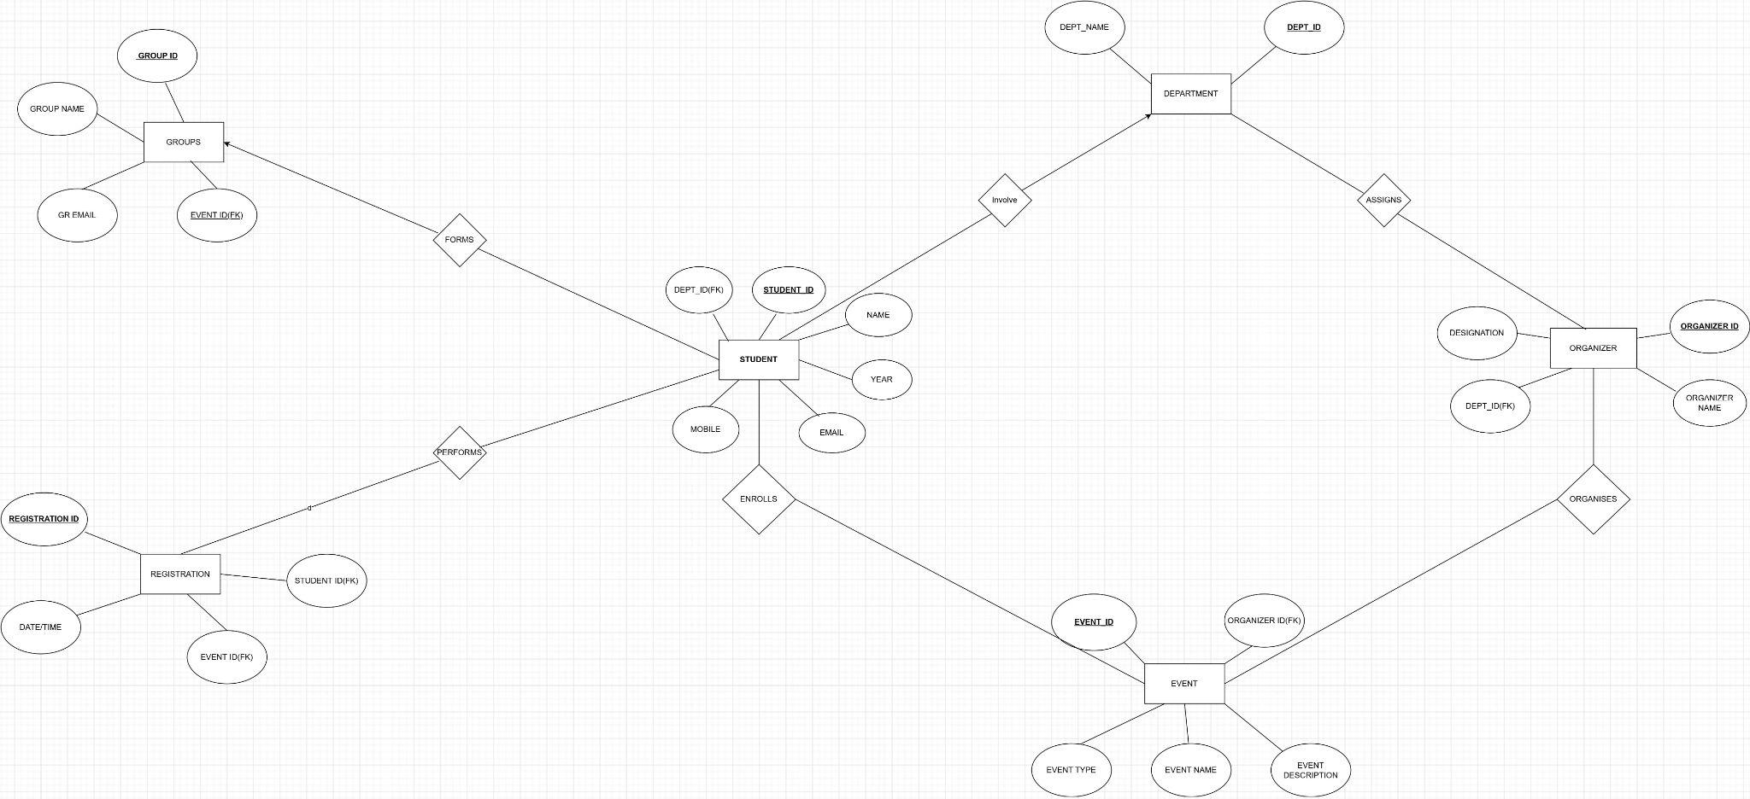

**\***

**UML diagrams**

1. **Use Case Diagram -**

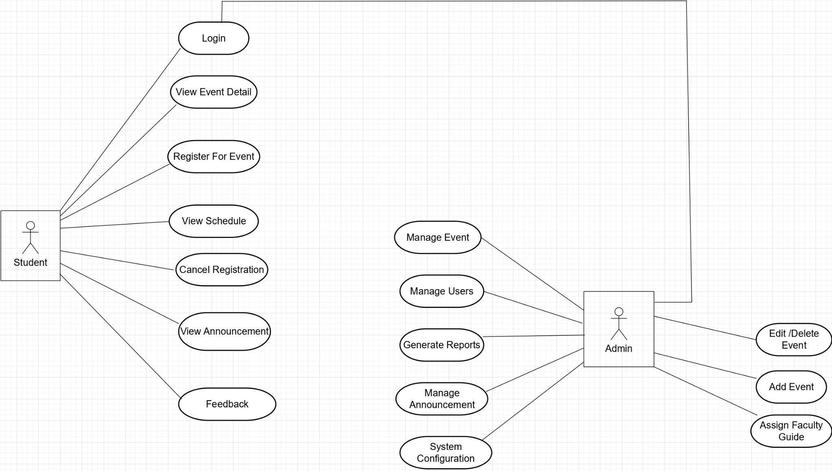

1. **Activity Diagram -** 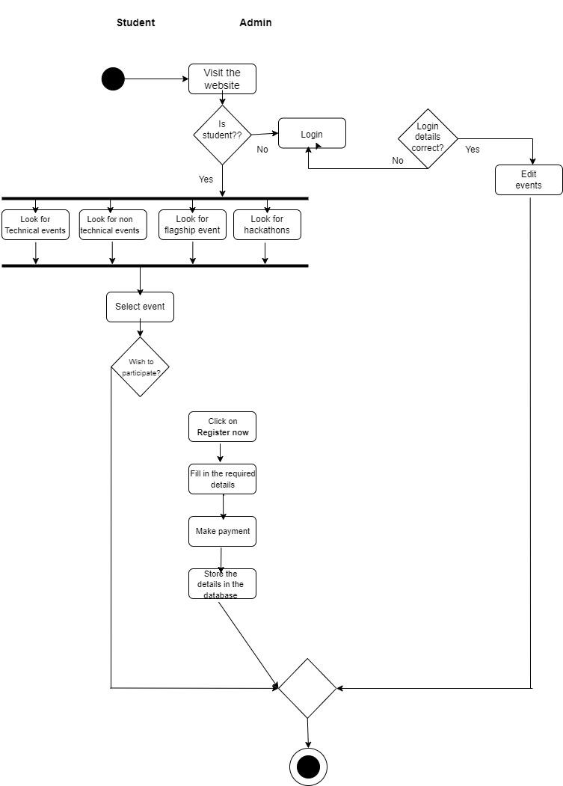

**Screenshots of project GUI**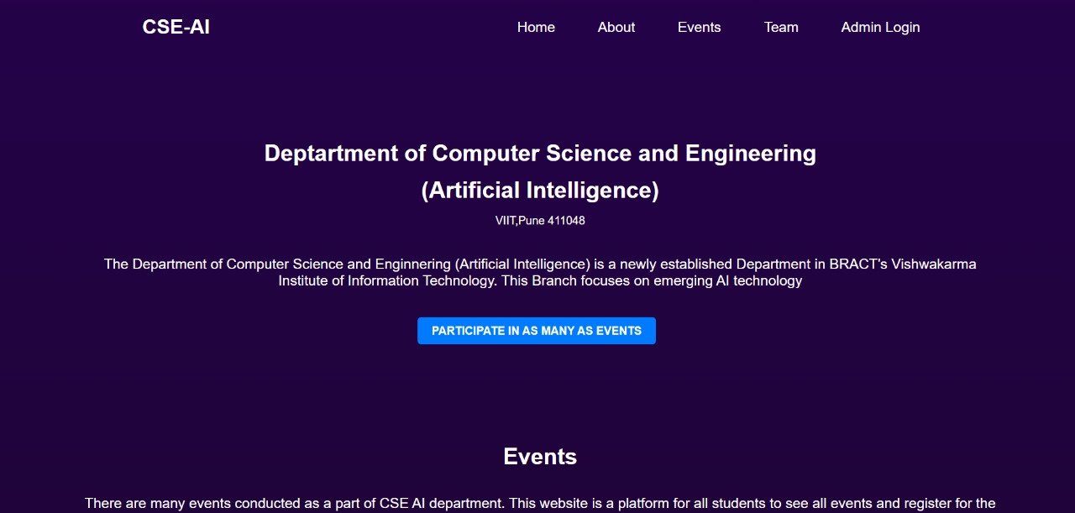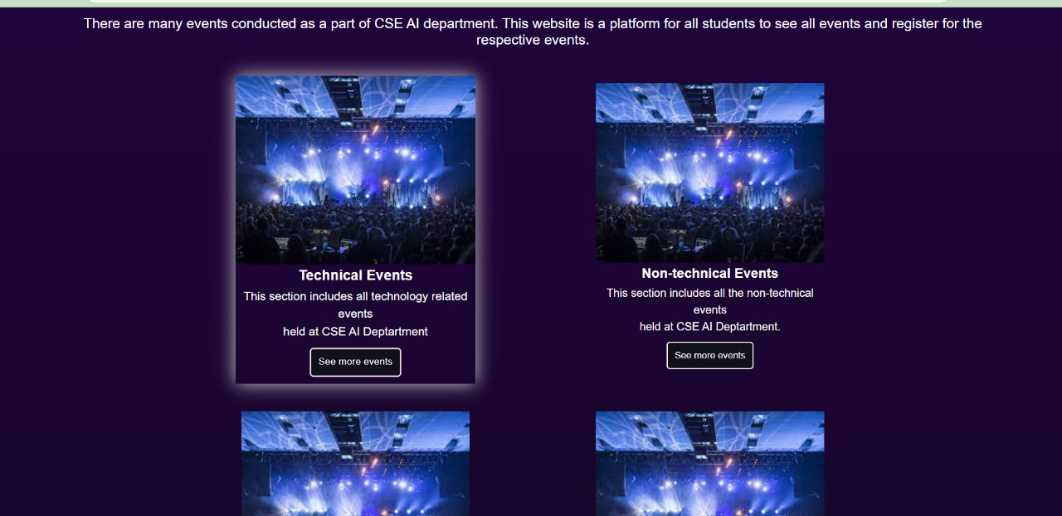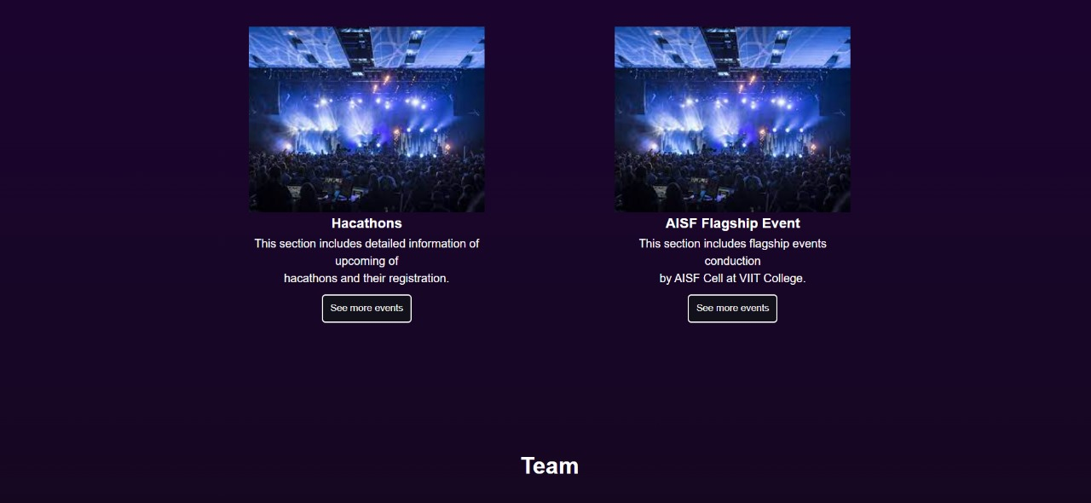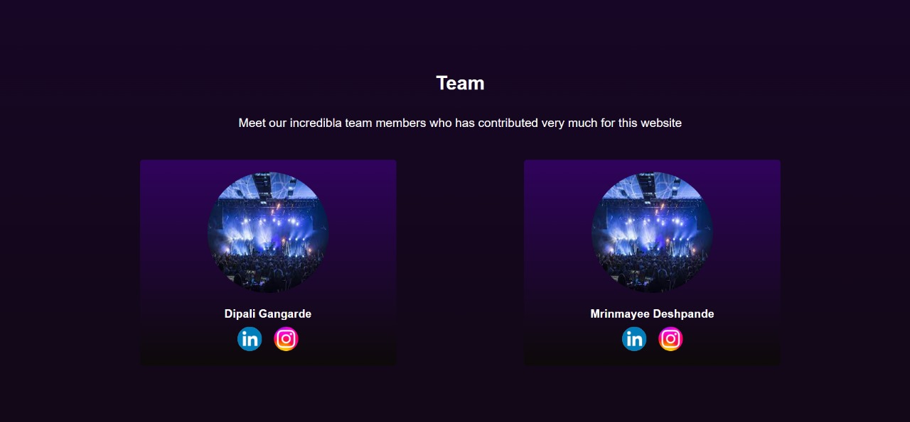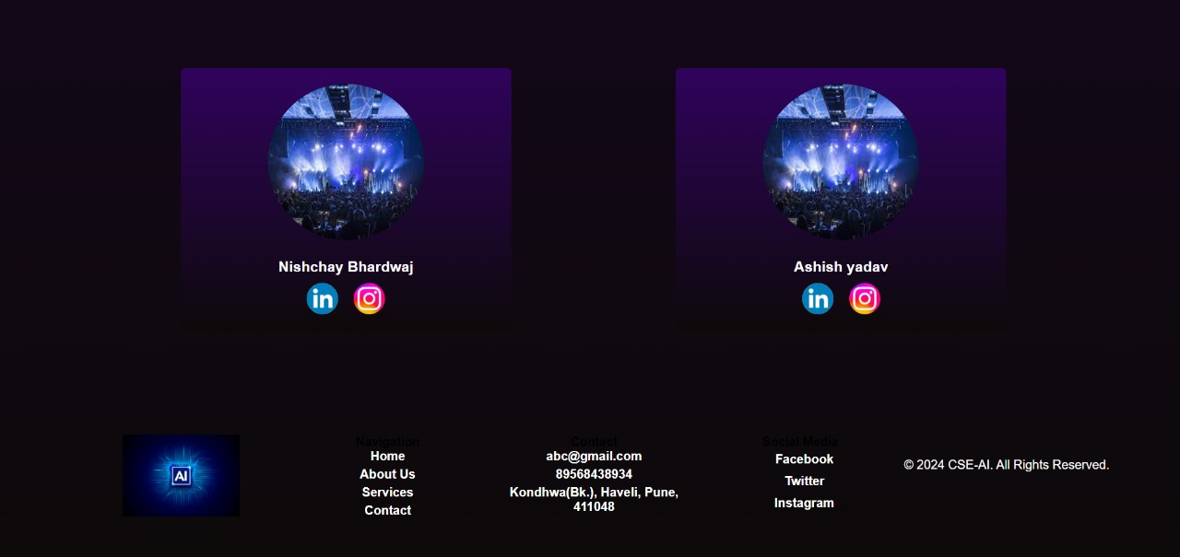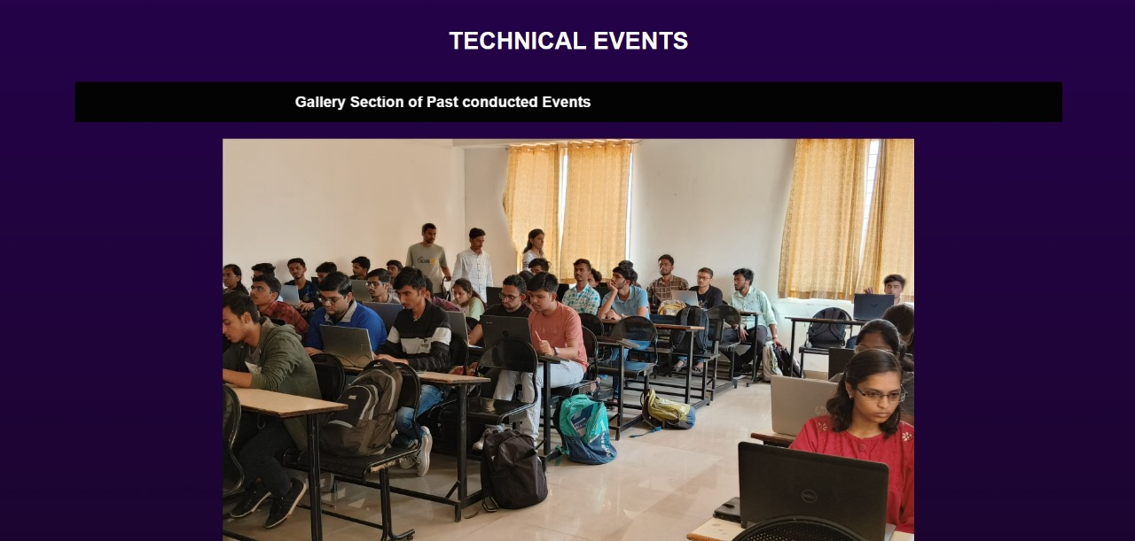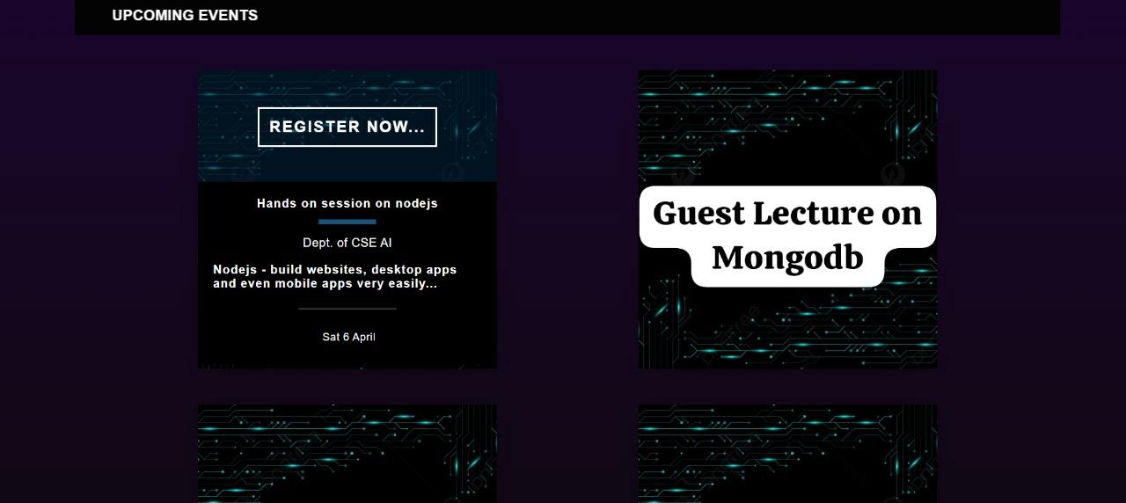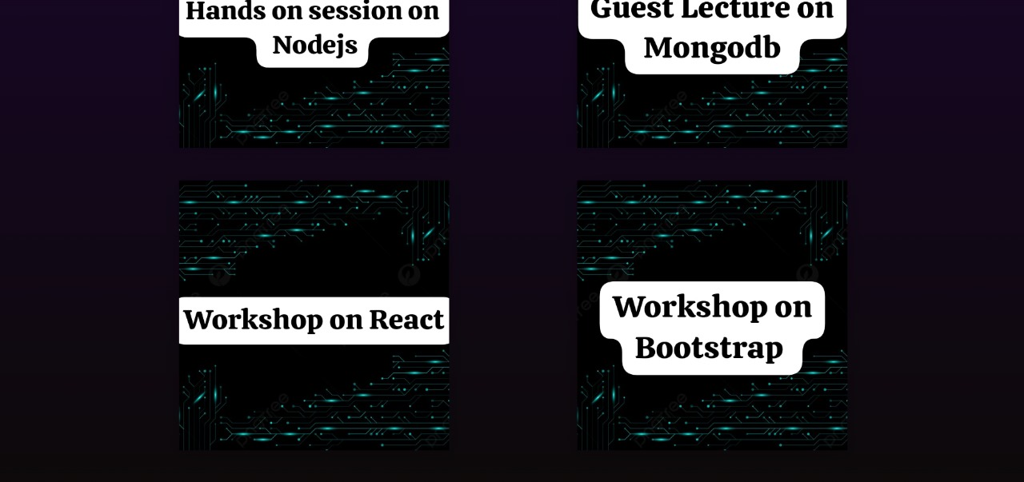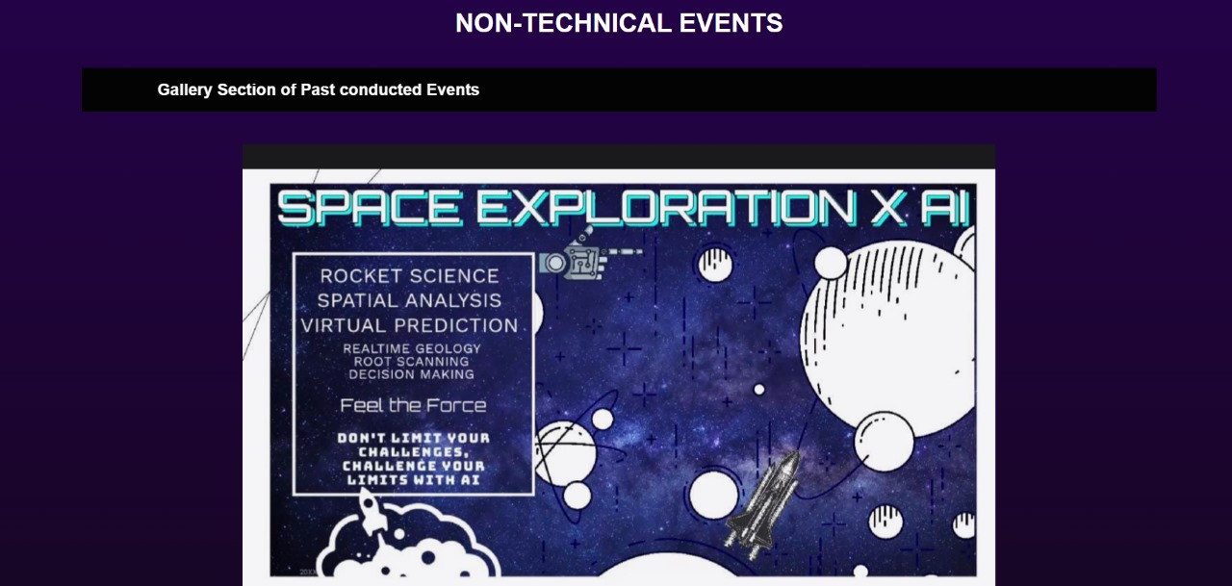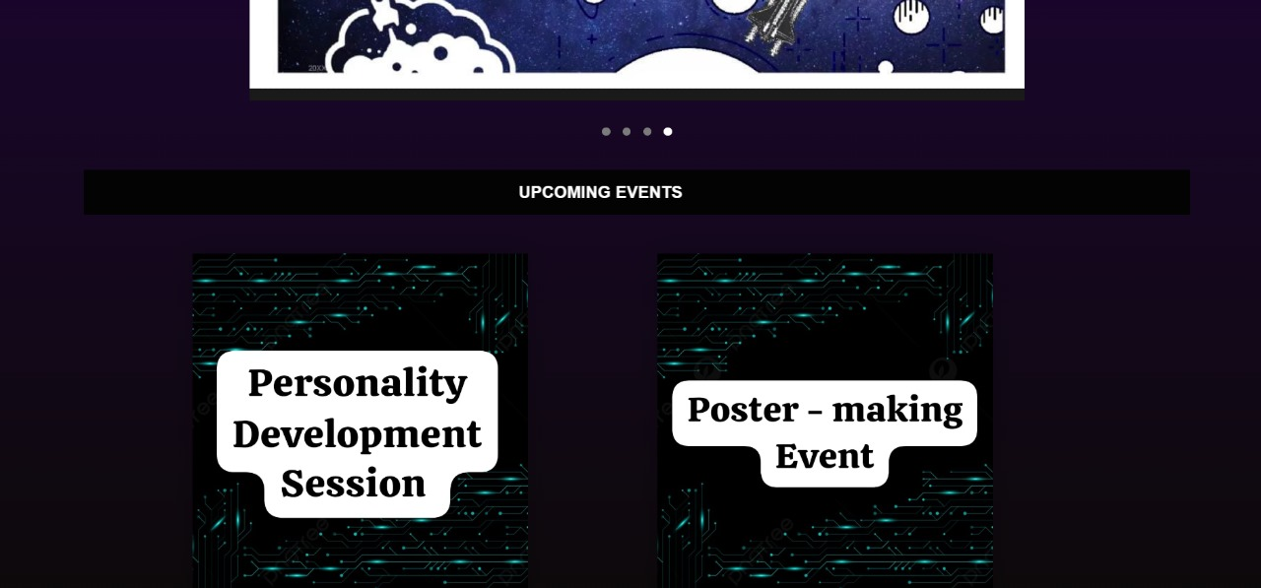

**Conclusion**

The Department-Specific Events Website project represents a groundbreaking solution to the challenges inherent in managing academic department events. Through the harmonious integration of frontend technologies like HTML and CSS with backend systems powered by Node.js and MongoDB, the project offers a seamless user experience for both students and administrators. Students benefit from a visually appealing interface that simplifies event discovery, registration, and payment processes, while administrators gain robust tools for event oversight and management. By leveraging modern technologies and user-centric design principles, the project streamlines event management processes, enhancing efficiency and accessibility within the department.

At its core, the project aims to foster a more dynamic and inclusive academic community by removing barriers to participation and engagement. By automating manual processes and providing real-time data insights, the platform empowers both students and administrators to navigate event coordination with ease and efficiency. With its transformative approach to event management, the Department-Specific Events Website project sets a new standard for academic event organization, paving the way for enhanced collaboration, innovation, and community-building within academic departments.